**Atlanta Population**

1. use db.zipcodes.find() to filter results to only the results where city is ATLANTA and state is GA. 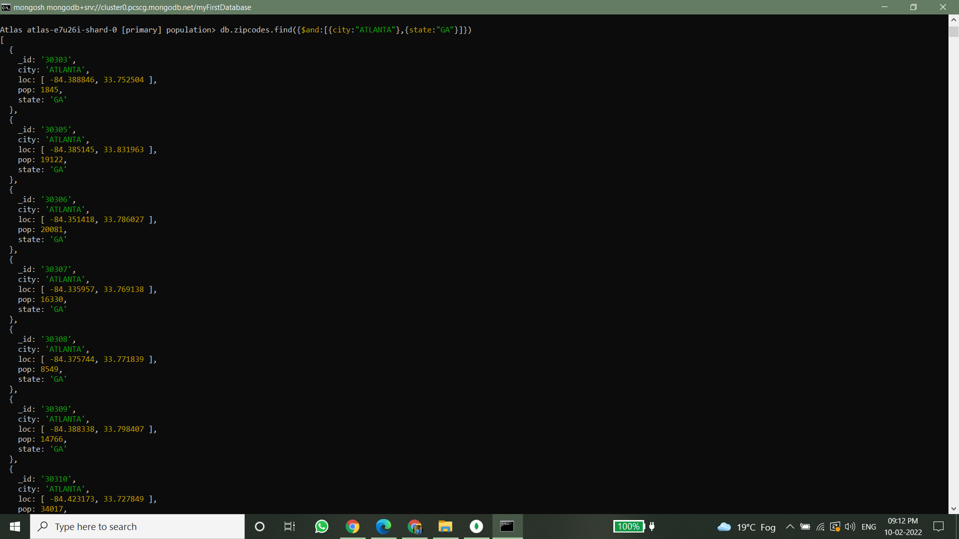

2. use db.zipcodes.aggregate with $match to do the same as above. 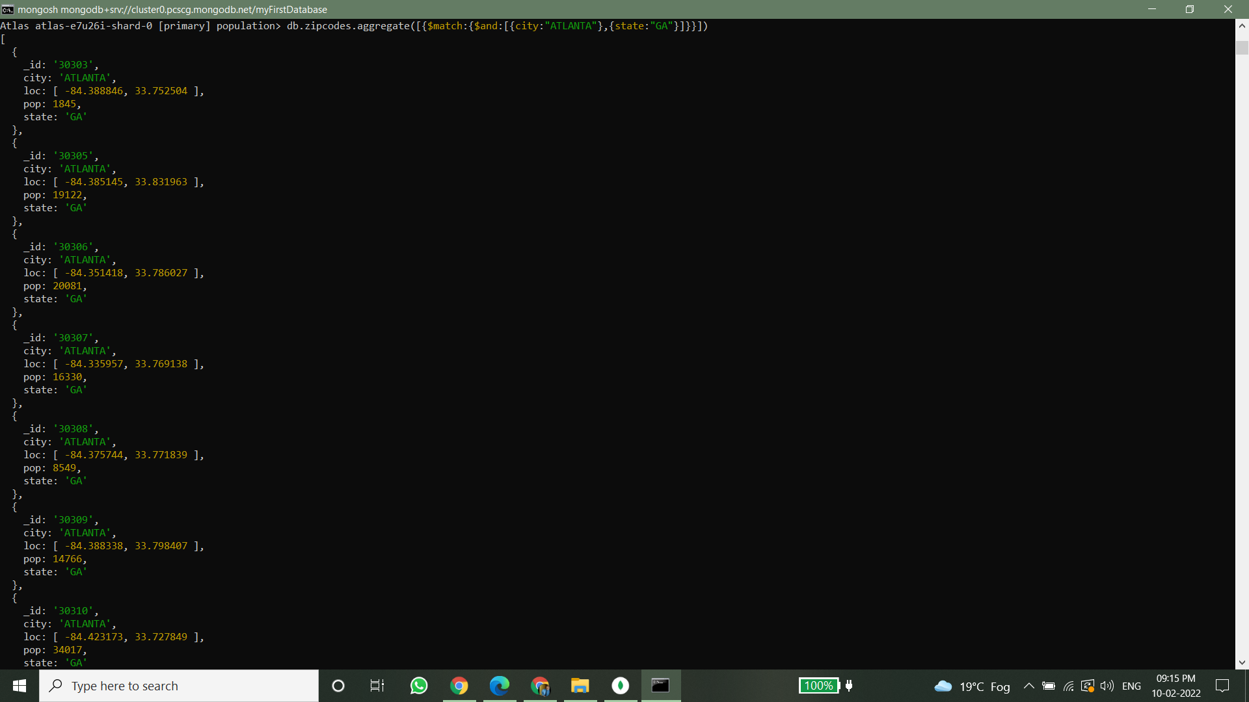

3. use $group to count the number of zip codes in Atlanta. 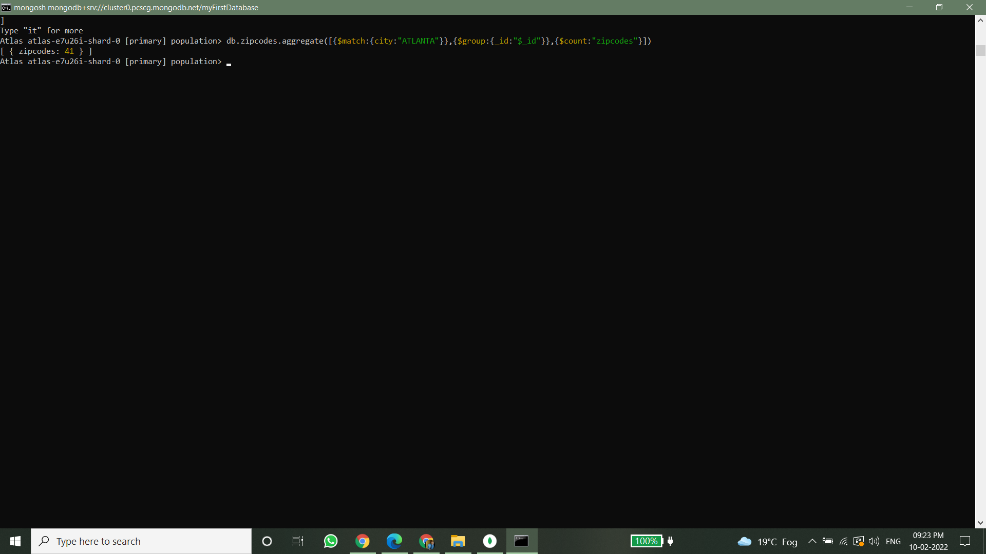

4. use $group to find the total population in Atlanta. 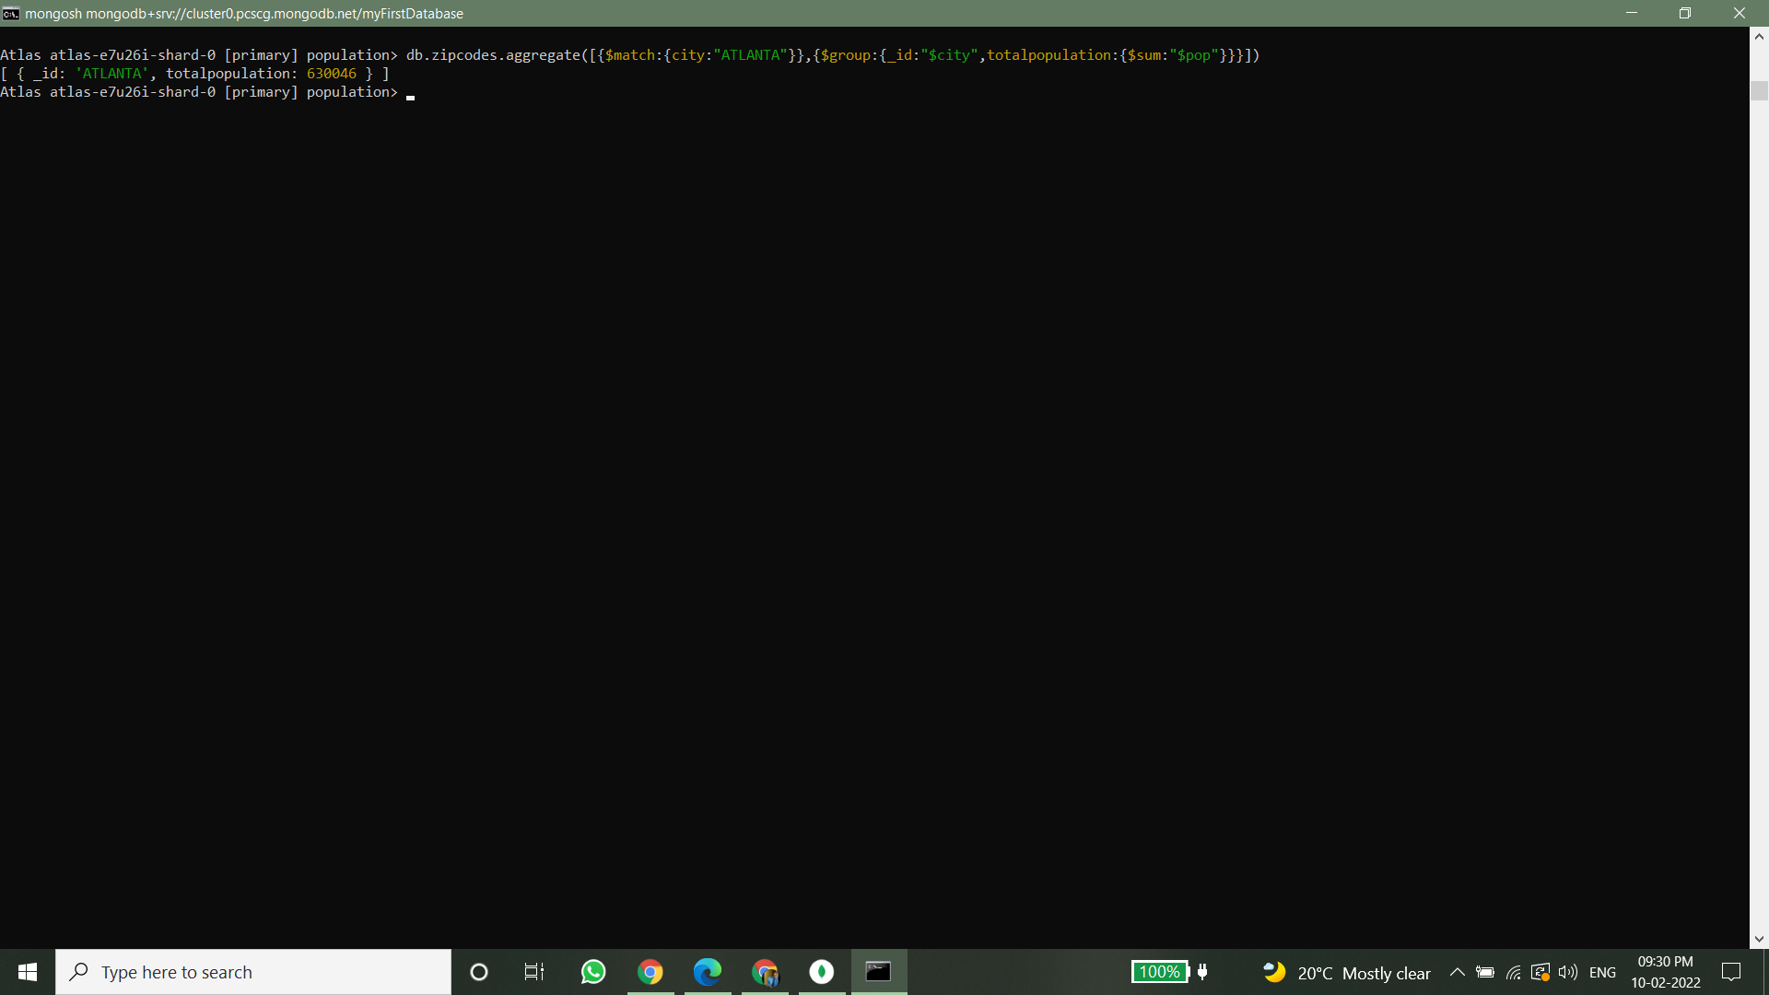

**Populations By State**

1. use aggregate to calculate the total population for each state 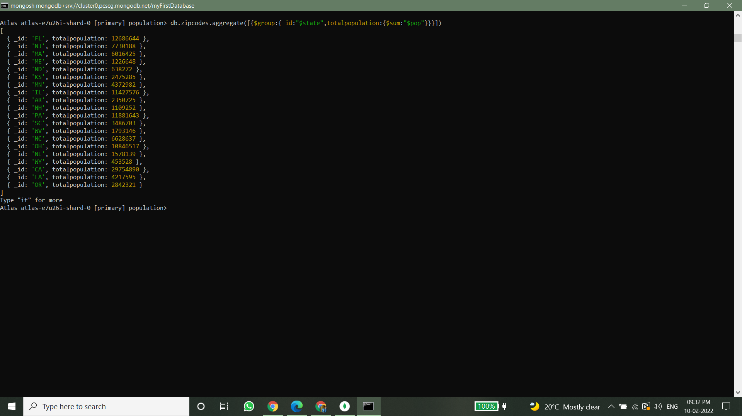

2. sort the results by population, highest first 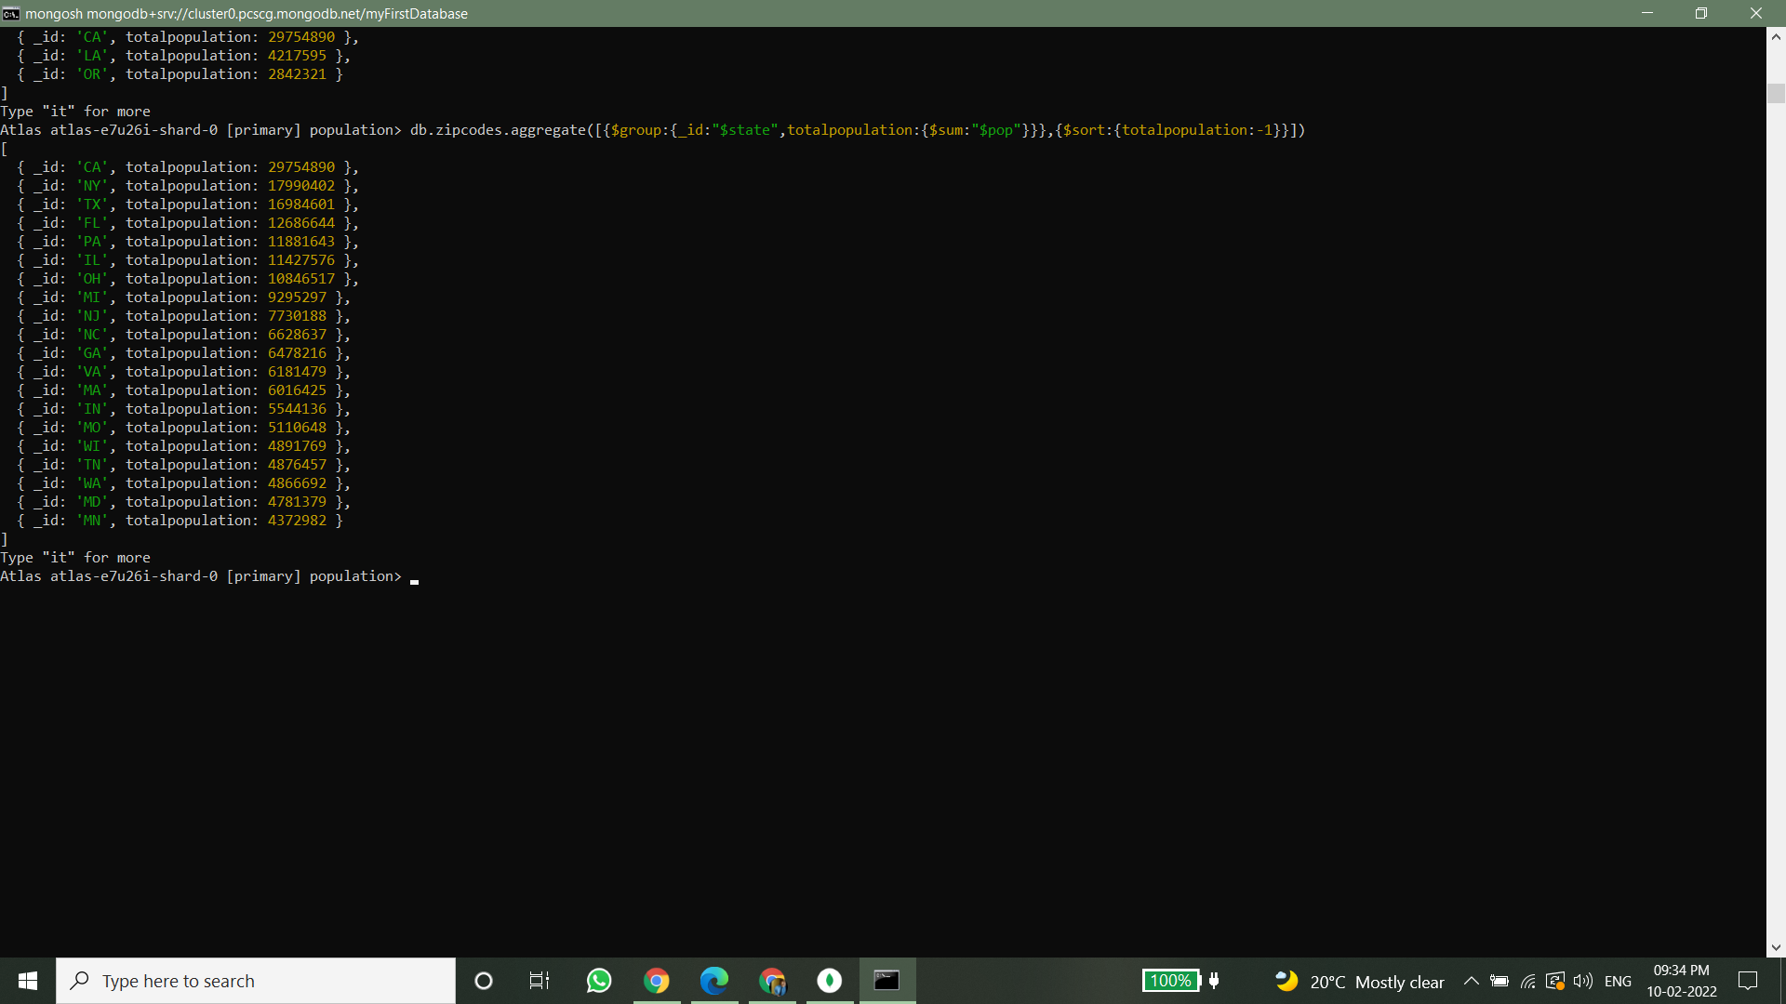

3. limit the results to just the first 3 results. What are the top 3 states in population? 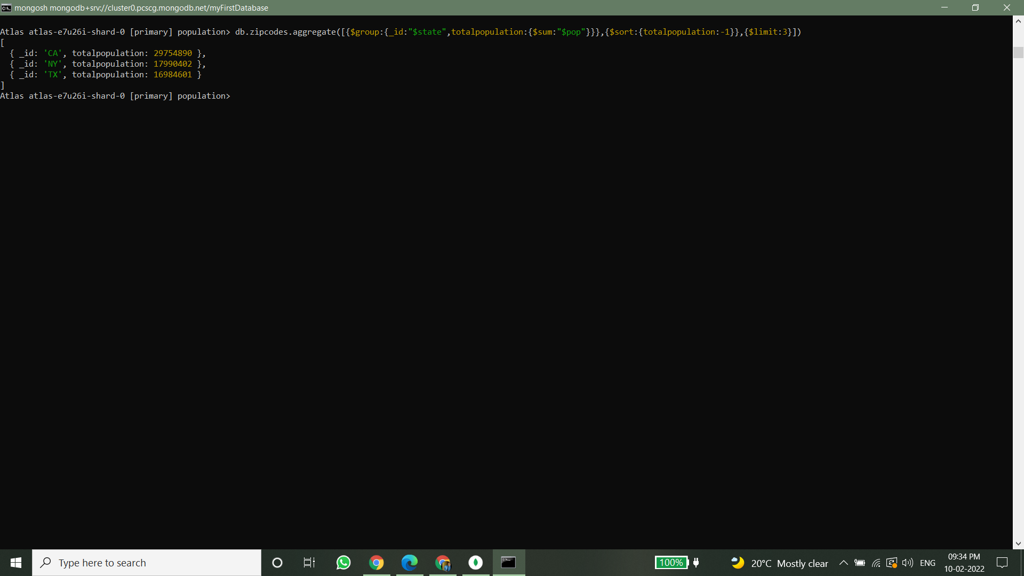

**Populations by City**

1. use aggregate to calculate the total population for each city (you have to use city/state combination). You can use a combination for the _id of the $group: { city: '$city', state: '$state' }

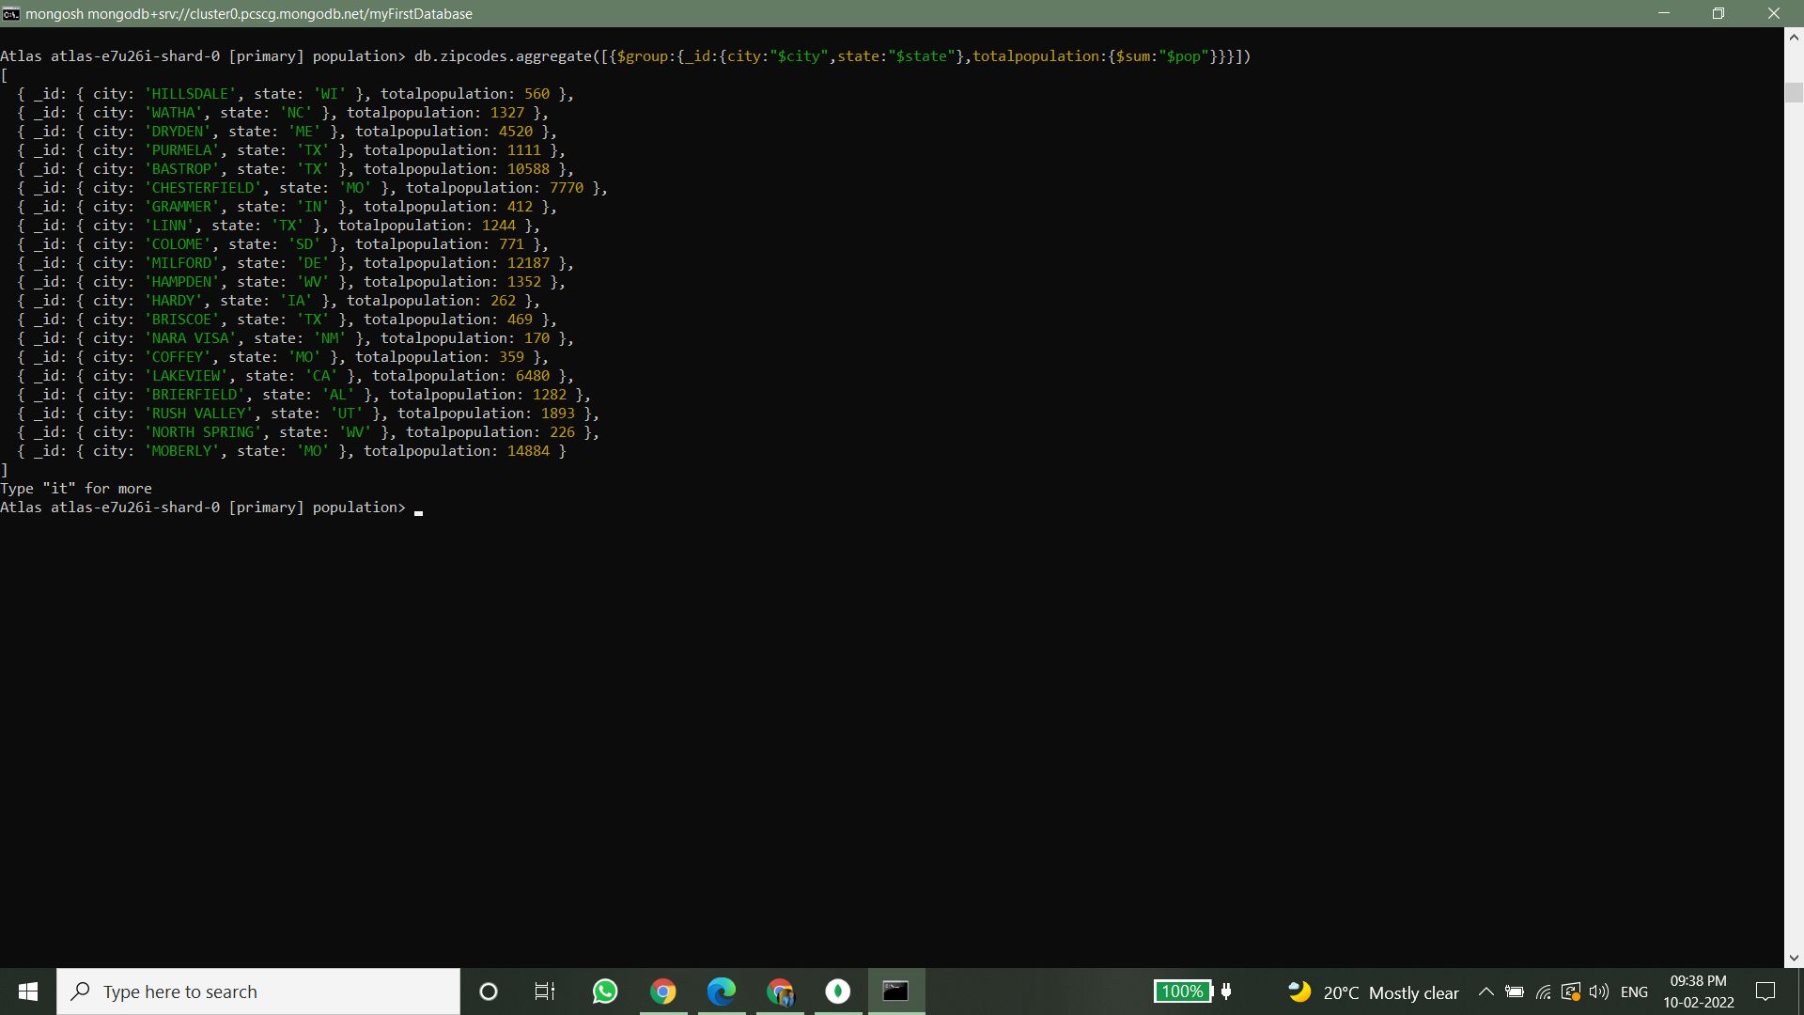

2. sort the results by population, highest first 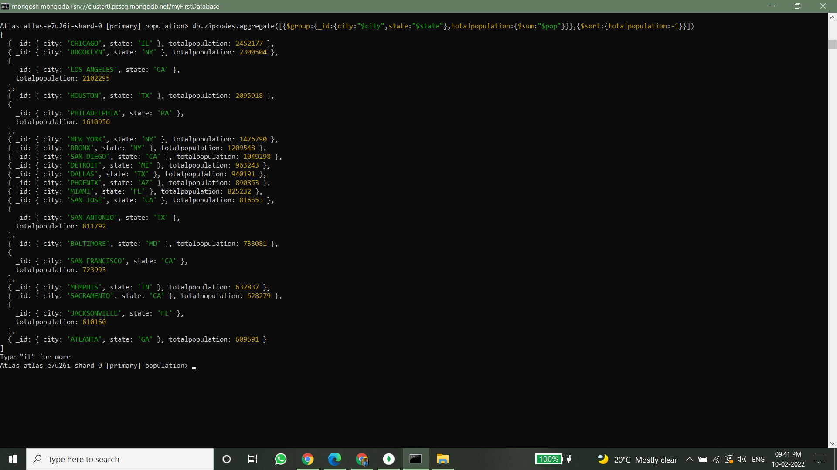

3. limit the results to just the first 3 results. What are the top 3 cities in population? 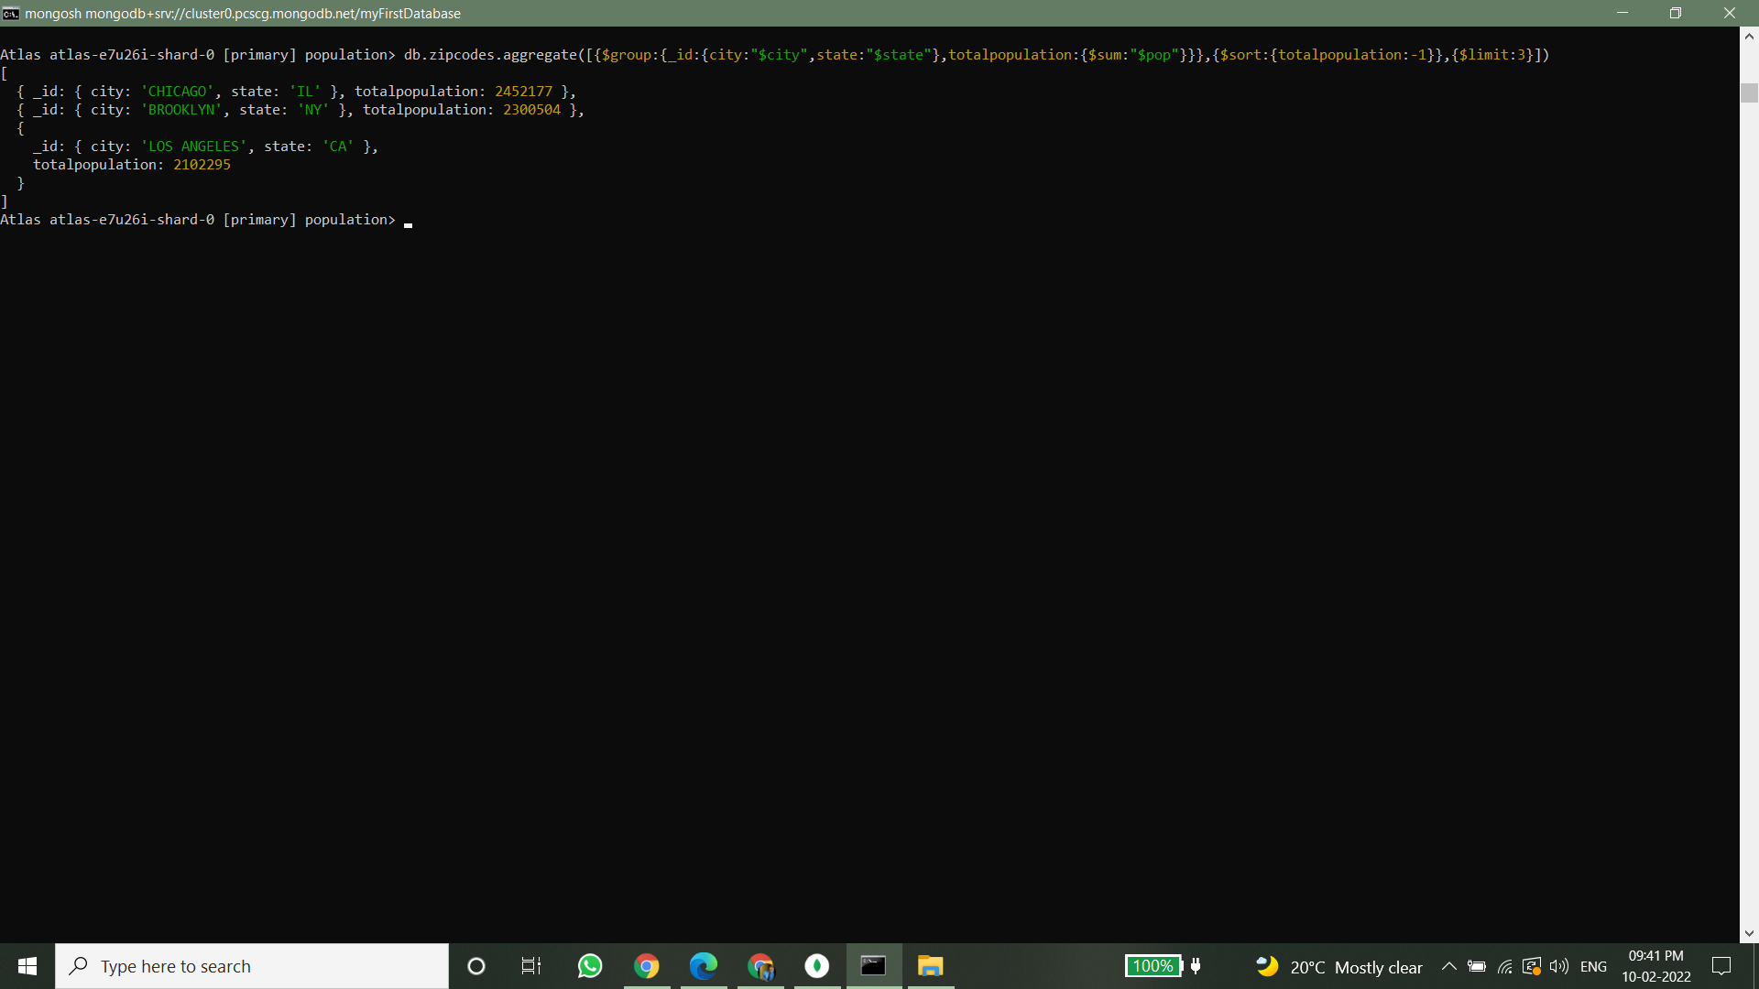

4. What are the top 3 cities in population in Texas? 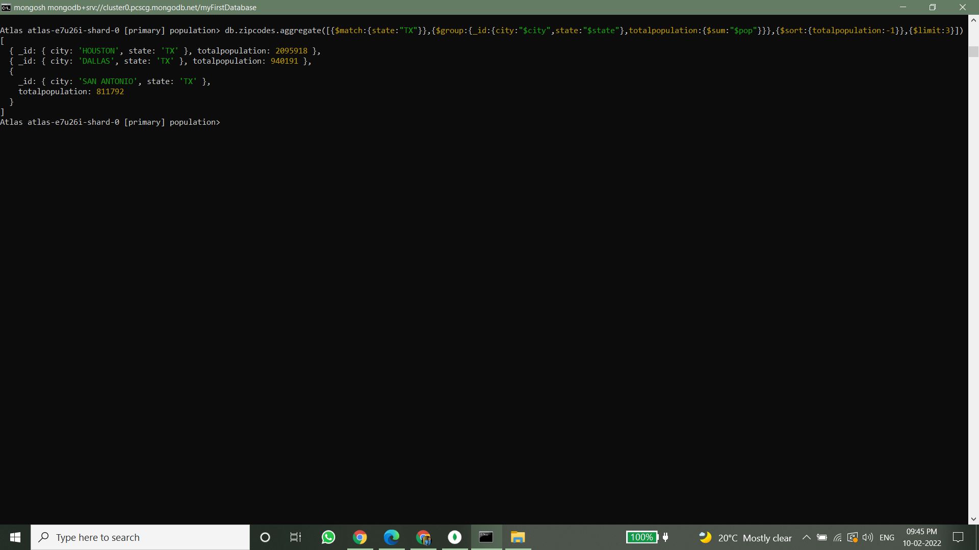

**Bonus**

1. Write a query to get the average city population for each state.

2. What are the top 3 states in terms of average city population

